

**Stages of Recovery**

|  |
| --- |
|  |

*“Stages of recovery” herein are modified from the work of Kathleen R. O’Connell, R.N., M.P.H., Ph.D. The first four are adapted from her book, Bruised by Life? Turn Life’s Wounds into Gifts. The 5th stage was developed by CCAR Executive Director, Phil Valentine, while training CCAR’s Recovery Coach Academy. They present a framework seeking to illustrate the ongoing, progressive nature of recovery.”*

**Stage of Recovery:**

* Stabilization
* Deepening
* Connectedness
* Integration
* Fulfillment

**Stage One- Stabilization**

The first stage of recovery is referred to as **Stabilization** and *generally occurs during the* ***first year*** *of recovery*. Stabilization is defined as **firmness of purpose and character**.

Some of the **tasks** in Stage One include:

* learning about addiction
* staying clean and sober no matter what
* physical detox and stabilization
* learning to socialize in a group setting
* learning to break the pattern of isolation
* developing role models for healthy recovery
* anxiety management
* staying away from risky places, situations and people
* developing self-responsibility
* learning to ask for help and support

*Who can relate to this stage? How?*

*How can we coach well?*

*How can we help build recovery capital?*

**Stage Two- Deepening**

The second stage of recovery is referred to as **Deepening** and *generally occurs during the* ***second year*** *of recovery*. Deepening is defined as **extending richness; a deeper understanding**.

Some of the **tasks** in Stage Two include:

* identifying old behaviors that don’t feel right anymore
* emotional detox
* changes in attitude, feeling and behavior
* increase in the quality of physical health
* increase in the ability to tolerate feelings
* beginning to make distinctions among feeling states
* increase commitment to working on recovery

*Who can relate to this stage? How?*

*How can we coach well?*

*How can we help build recovery capital?*

**Stage Three- Connectedness**

The third stage of recovery is referred to as **Connectedness** and *generally occurs during* ***years three to five*** *of recovery*. Connectedness is defined **as joining together; to think of as related**.

Some of the **tasks** in Stage Three include:

* the depth of joy and misery can be profound
* the need to go back and redo some earlier tasks in recovery
* learning to avoid creating drama in life
* the outer world is beginning to reflect the person’s inner world
* connections are made to a wider circle of people both in and out of recovery
* an increase in honesty

*Who can relate to this stage? How?*

*How can we coach well?*

*How can we help build recovery capital?*

**Stage Four- Integration**

The fourth stage of recovery is referred to as **Integration** and *generally occurs during* ***years six to ten*** *of recovery*. Integration is defined as **becoming whole**.

Some of the **task**s in Stage Four include:

* relationships based on love rather than need
* avoiding “stuckness”
* automatic use of tools of recovery
* an ability to act on knowledge and insight; and follow through
* self-forgiveness
* having fun and joy in life

*Who can relate to this stage? How?*

*How can we coach well?*

*How can we help build recovery capital?*

**Stage Five- Fulfillment**

The fifth stage of recovery is referred to as **Fulfillment** and *generally occurs* ***after ten years*** *of recovery.*

Some of the **tasks** in Stage Fifth include:

* discovering and following through on life purpose
* living with an aura of peace/serenity
* dramatic reduction in worry
* acceptance
* confidence balanced with humility
* embracing the concept of being both precious and insignificant at the same time
* gratitude penetrates all actions

*Who can relate to this stage? How?*

*How can we coach well?*

*How can we help build recovery capital?*

***How is this part of taking your recoveree where he or she is at?***

***Does this shed any light on your experiences in your own recovery?***

**What’s this:**

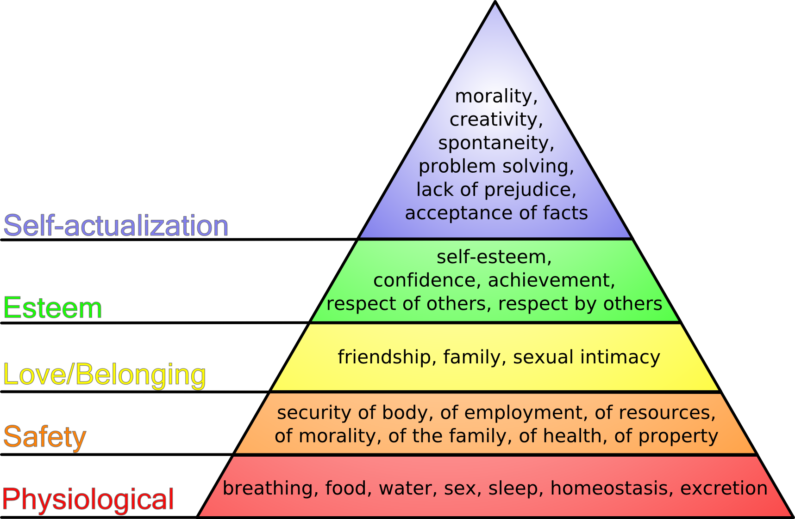

**Any thoughts or comments?**