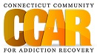

**Stages of Change**

|  |
| --- |
|  |

The Stages of Change is a model developed by *Prochaska and DiClemente* in 1982 and is commonly used to as a basis for developing effective behavior interventions. Where as most may see the need to change a behavior as an event, (quit smoking, drinking, etc.) this model shows that change is a process that goes through five stages. Change is often accompanied by supports and challenges. By looking at the dynamics of the stages of change, we may better understand the process.

*The five stages of change are:*

* **Precontemplation**
* **Contemplation**
* **Preparation**
* **Action**
* **Maintenance**

**Stage of Change: Precontemplation**

* Person shows no intent to change a problem behavior
* Person may be unaware behavior is a problem, or unwilling to do anything about it
* Person may lack confidence to change a problem behavior due to previous failed attempts
* Person may view behavior as being more positive than negative
* Person believes behavior to be under control or at least manageable

**Stage of Change: Contemplation**

* Person is considering change, but has not yet initiated any change
* Person is considering implications and consequences of behavior
* Person is visibly distressed by target behavior
* Person has started to weigh the positive and negatives of the behavior
* Person will typically seek out relevant information about the behavior

**Stage of Change: Preparation**

* Person is getting ready to change the behavior, both in attitude and behavior
* Person intends to change **soon**
* Person may have already started to increase self-regulation around specific behavior
* Person may been prepared to make or may already be making small changes to the behavior

**Stage of Change: Action**

* Person is actively making change to behavior
* Person is modifying their attitudes and responses to behavior
* Person is learning skills to prevent relapse or reversal of specific behavior
* Action stage typically(?) lasts an average of 6 months in people working to change substance use.

**Stage of Change: Maintenance**

* Person sustains and strengthens changes made to the behavior
* Person is practicing skills to prevent relapse or reversal of behavior
* Establishes basic “habits” or “rituals” around modified behavior

***The stages of change are generally considered cyclical and not linear with people moving back and forth between stages.***

*“What insights can we gain from this framework, particularly as it relates to recovery coaching?*

*Does this make sense in taking your recoveree where he or she is at?*

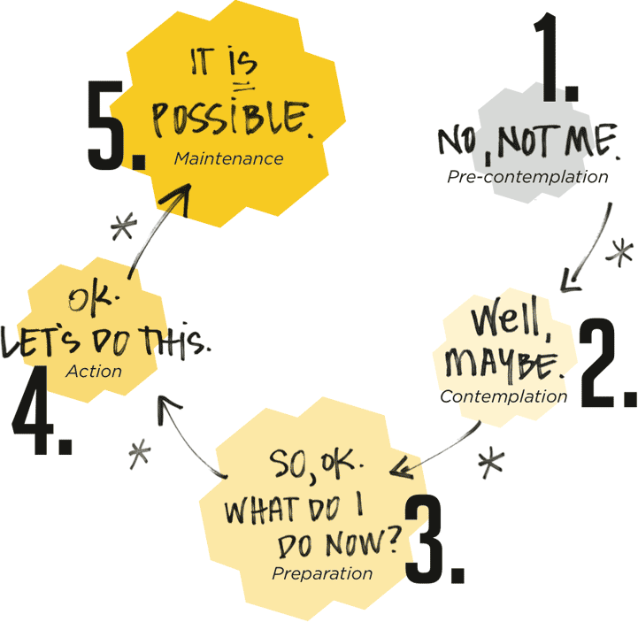

**Stages of Change**

|  |  |  |  |
| --- | --- | --- | --- |
| Stage | Common Characteristics | Recoveree Task | **Recovery Coach Role** |
| ***Precontemplation***-No intent to change problem behavior.  -May be unaware behavior is a problem.  -May lack confidence to change behavior due to previous failed attempts.  -Tends to view behavior as having more positive than negative.  -Believe behavior to be under control or at least manageable. | -Defensive.  -Resistant to suggestions of problems created by the addiction.  -Uncommitted or passive in treatment.  -Avoids steps to change use associated with the addiction.  -Lacks awareness of the problem.  -Often pressured or mandated to seek treatment. | *Precontemplation to Contemplation*  -Acknowledge the problem.  -Recognize the harm caused by the addiction.  -Increase awareness of negatives of the addiction.  -Begin building confidence and self-efficacy. | *Precontemplation to Contemplation*  -Raise doubts.  -Increase concern and awareness associated with the addiction.  -Develop hope and optimism.  -Begin to develop discrepancy. |
| ***Contemplation***  -Considering change, has not yet initiated any change behavior.  -Considering implications and consequences of behavior.  -Starting to weigh the positives and negatives of the behavior.  -Typically seeks out relevant information about the target behavior. | -Seeking to evaluate and understand the addiction.  -Distressed about the addiction.  -Desire to exert control over the addiction.  -Thinking about making change.  -Have not started to make change.  -Not prepared to make change. | *Contemplation to Preparation*  -Make a decision to act.  -Commit to change.  -Take first steps towards making change.  -Resolve ambivalence. | *Contemplation to Preparation*  -Examine the impact of the addiction.  -Consider the pros and cons of the addiction in order to tip the decisional balance in favor of commitment to change. |

|  |  |  |  |
| --- | --- | --- | --- |
| ***Preparation***  -Getting ready to change, both the specific behavior and the attitude.  -Intends to change soon.  -May have already increased self-regulation around behavior.  -May be prepared to make small changes.  -May already be making small changes. | -Intending to change addictive behavior.  -Ready and committed to change.  -On the verge of taking action.  -Engaged in the change process.  -Ready to make firm commitments. | *Preparation to Action*  -Establish priorities.  -Set goals for achieving change.  -Develop a plan for change. | *Preparation to Action*  -Strengthen the commitment to change.  -Help develop an action plan and strategies that facilitate the desired change. |
| ***Action***  -Actively making change to target behavior.  -Modifying attitudes and responses to behavior.  -Learning skills to prevent relapse.  -Action stage typically lasts an average of 6 months in people working on an addiction. | -Decision to make change.  -Firm commitment to change.  -Involvement in process of change.  -Efforts to change behavior and environment.  -Motivated.  -Willing to follow suggested strategies and activities. | *Action to Maintenance*  -Apply behavior change methods and techniques for at least 6 months.  -Develop self-efficacy.  Refine change behavior.  Actively meet recovery goals. | *Action to Maintenance*  -Support the ongoing implementation and modification of the plan for change.  -Support development of new behaviors and attitudes conducive to change. |
| ***Maintenance***  -Sustains and strengthens changes addressing specific behavior.  -Practicing skills to prevent relapse.  -Establishing basic habits and rituals around modified behavior. | -Achieving change.  -Working to sustain change.  -Focus on avoiding relapse.  -May be experiencing anxiety and fear around relapse.  -Becoming aware of high risk situations and developing strategies to cope with them. | *Maintenance*  -Develop routines.  -Become aware of the positives associated with the change.  -Practice healthy attitudes (gratitude, service, hope, encouragement, etc.). | *Maintenance*  -Celebrate!  -Encourage.  -Reinforce positives.  -Notice the progress made by the recoveree.  Focus on other quality of life issues. |

**What Stage of Change is someone at if:**

1. He has just lost his job because of his drinking and he is pissed that his employer is blaming him for his performance instead of his incompetent co-employees.
2. She is a few of months out of treatment and regularly going to NA meetings, but her life hasn’t gotten any better and it still sucks?
3. He has not been able to stop drinking for longer than a month on his own, but he wants to and wants to get some kind of help but does not want to go away to treatment or hang out with those AA people?
4. She has lost her job and is afraid to tell her husband, because despite many warnings, she was often late to work and smelled like booze?
5. He is afraid to do the fourth and fifth step with his sponsor because he is ashamed of some of the things he has done and fears he will lose a good friend if he reveals himself?
6. She has lost her kids to DCF and lives with a guy who regularly abuses her, but she doesn’t really care as much about these things as much as her nagging mother does?
7. He regularly comes to CCAR and asks for help in getting a detox bed, but always finds a reason to leave if one isn’t immediately available?
8. She sincerely wants to stop using and will be ready to quit once she finds a good job?